**M1 - Explain the role of web architecture in website communications**

**Introduction**

In this report, I will be explaining what web 2.0 and cloud computing means in a website.

**Web 2.0**

Web 2.0 is a new version of the World Wide Web. The layout of the whole specification is changed. It allows the user to interact and communicate with each other. The web 2.0 has a limited application. It is the following:

* Social Networking Site
* Blogs
* Web

However, these have changed, and this is an upgraded version of Web 1.0. These are all seen as components of the Web 2.0. The image below shows some of the content.

[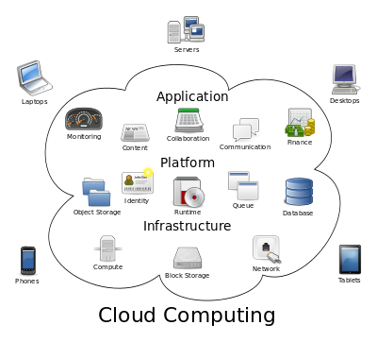](http://en.wikipedia.org/wiki/File:Cloud_computing.svg)

**Cloud Computing**

Cloud computing is in which large groups of servers are grouped together to allow others for a use of service. Clouds can be classified as public, private or hybrid. Some of the content of it can be taken off for the users not be allowed to be looked at. Some of them can be private, so that others only people that are allowed can access it.

**Blogs**

A blog is a web page that provides a user information on an individual topic that a user chooses to do. Blogs have come popular in the recent century, and people can express their opinion about the topic they have chosen. Others can register and join in with them. For example, there is a topic about whether to go university or not? People can put their information in to help out the user that is finding information. Some topics available could be and what types of things could be available:

* Any subject e.g. IT, Maths, GCSEs, A levels etc.
* 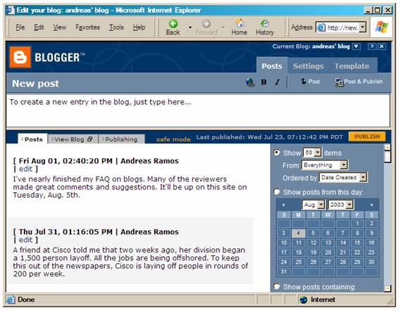Images
* Videos
* Texts

**Online Application**

An online application is a program that grants the user to give features using the internet. These types of applications have to use the application software for the online application to open. These online application can take time to download, depending on the size of the application. They are many types of software that use the online application. Some of these are the following:

* Microsoft Office – including all of them.
* Adobe Dreamweaver
* Any software



**Reference**

<http://en.wikipedia.org/wiki/Web_2.0>

<http://en.wikipedia.org/wiki/Cloud_computing>